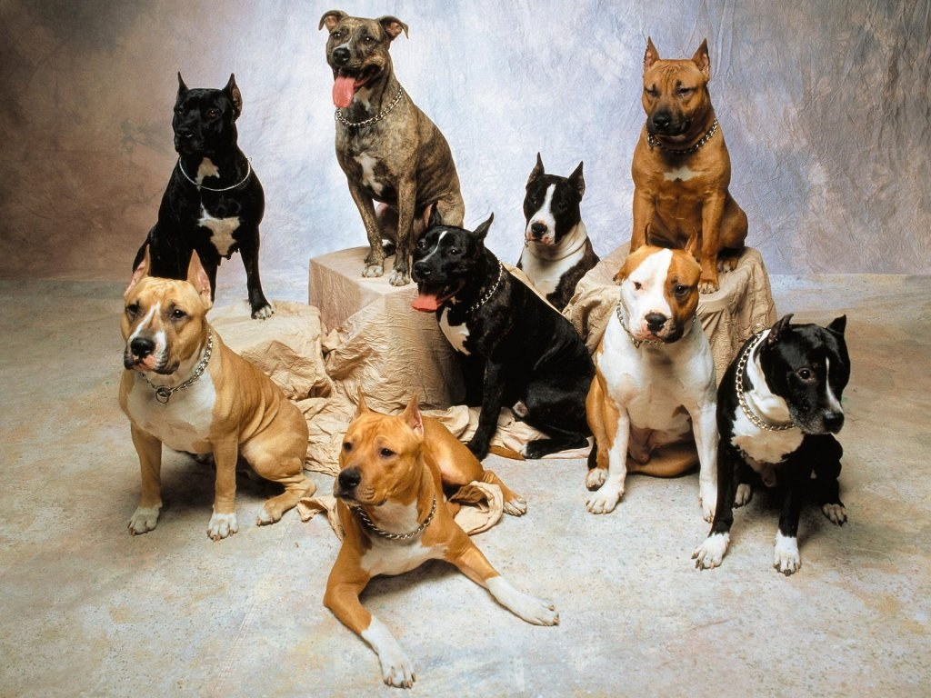

Dogs and reasons why i like them by:Camila
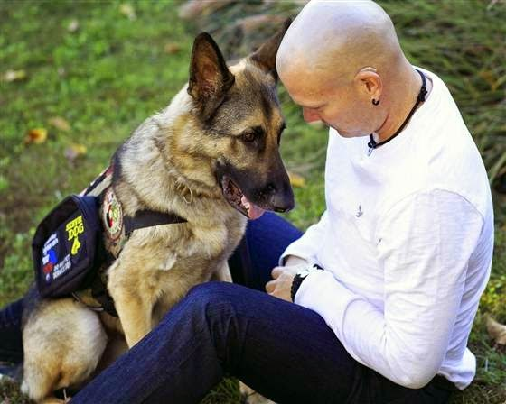
1 - There is a million dogs all around the world helping so many people that need help. Some examples are Police and Firefighters. Dogs don't only help the service they can also help you.
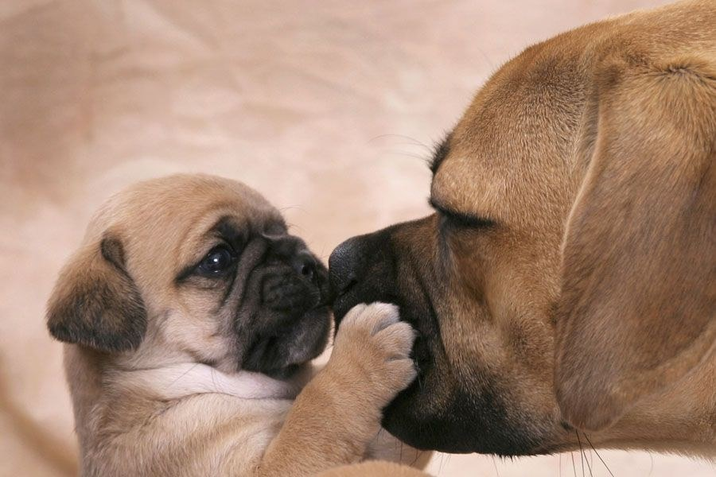
2 - Dogs are sweet and caring. They love to cuddle and are nice company.
3 - Dogs come in all shape and sizes and whatever size they are they still are so cute and adorable. They love cuddles and get so exited when you get home.They are also really loyal to their owners.
4 - Dogs are really smart. Even tho they cant understand human language they have a way of knowing how you feel. Dogs can understand facial expressions. They know when we are rushed,relaxed,happy,mad,focused,or available for play time!
10 amazing did you know facts about dogs I thought were impressive..
Did you know that the tallest dog in the world is 44 in. tall!
Did you know that a greyhound could beat a cheetah in a race!
Did you know basenji dogs don't bark, they yodel!
Did you know 3 dogs survived the titanic sinking !
Did you know the Saluki is the oldest dog breed!
Did you know that dogs have 3 eyelids!
Did you know the African hunting dog is the most successful hunter in the world!
Did you know the Beatles song 'A Day in the Life' has a frequency only dogs can hear!
Did you know Newfoundlands are amazing lifeguards!
Did you know dog's noses are wet to help absorb scent chemicals!
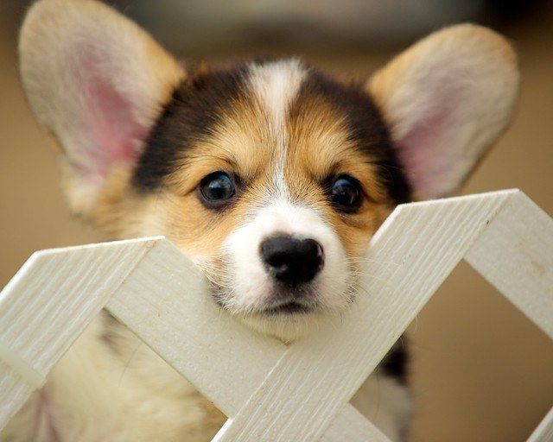
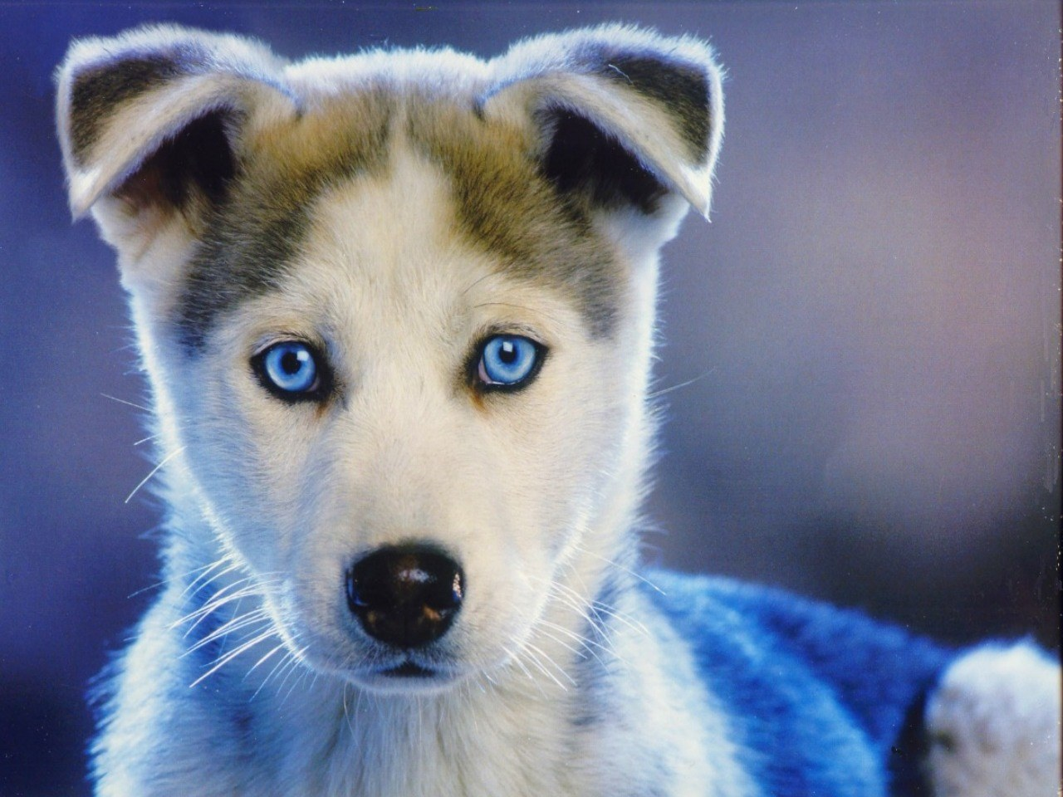
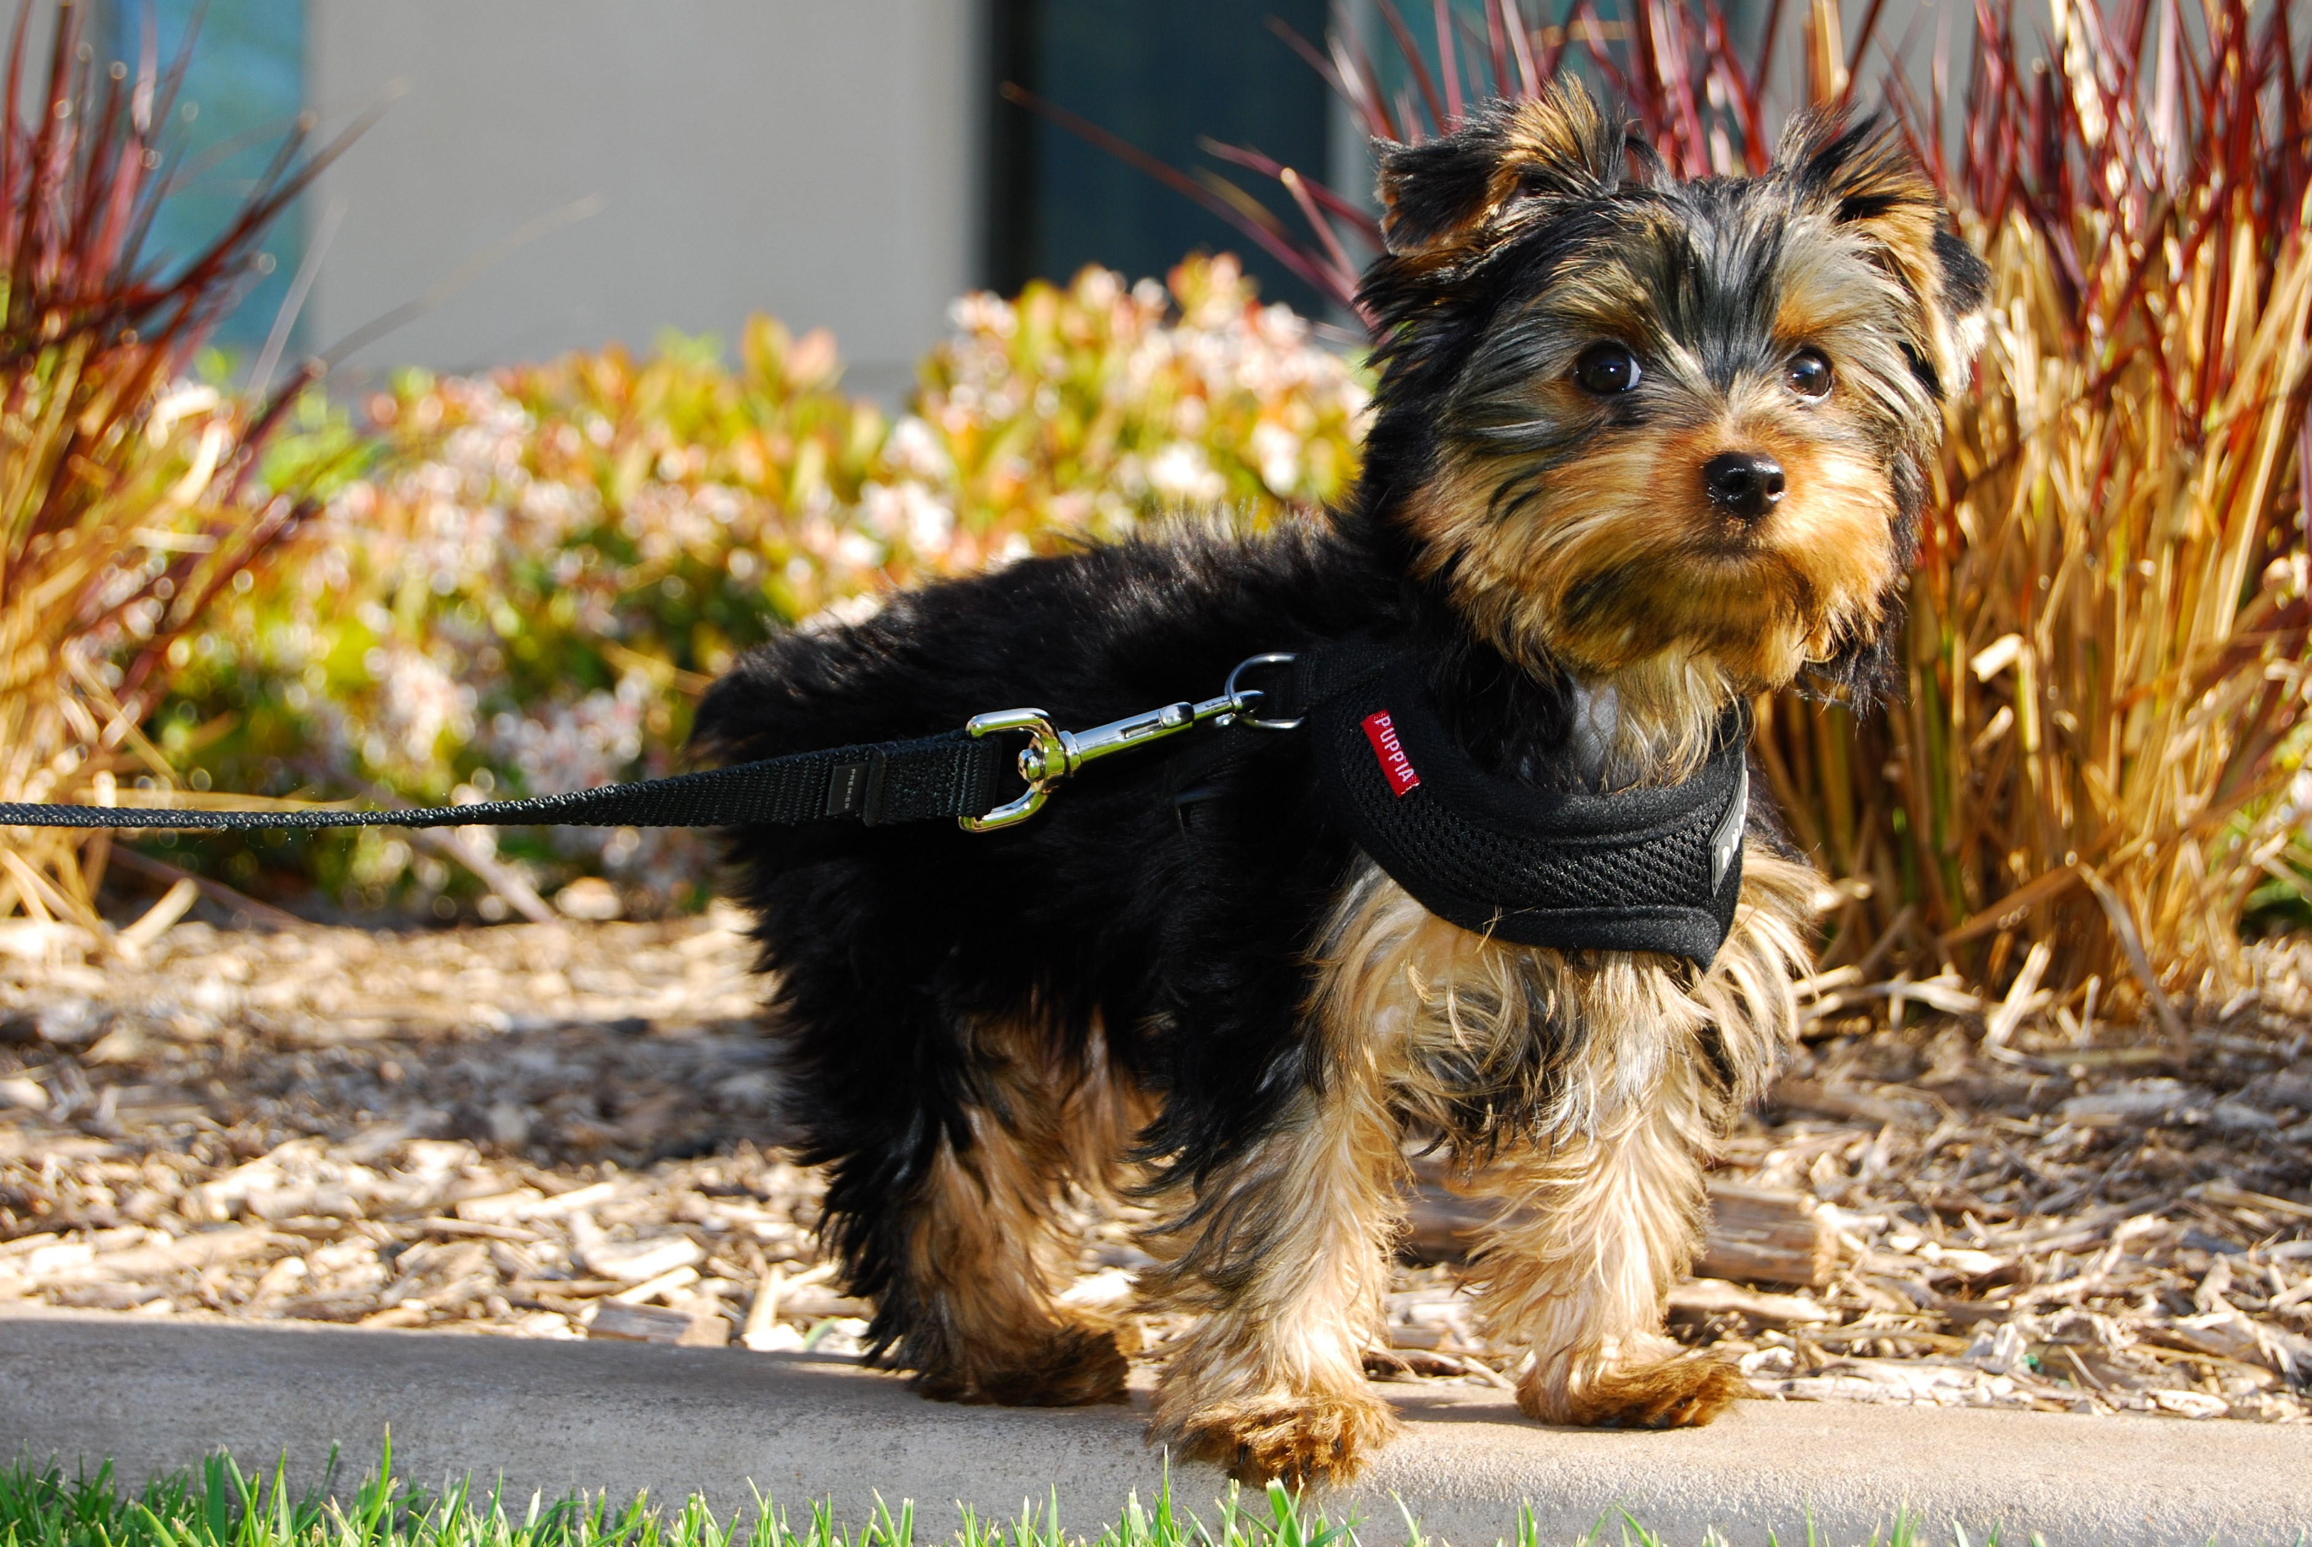
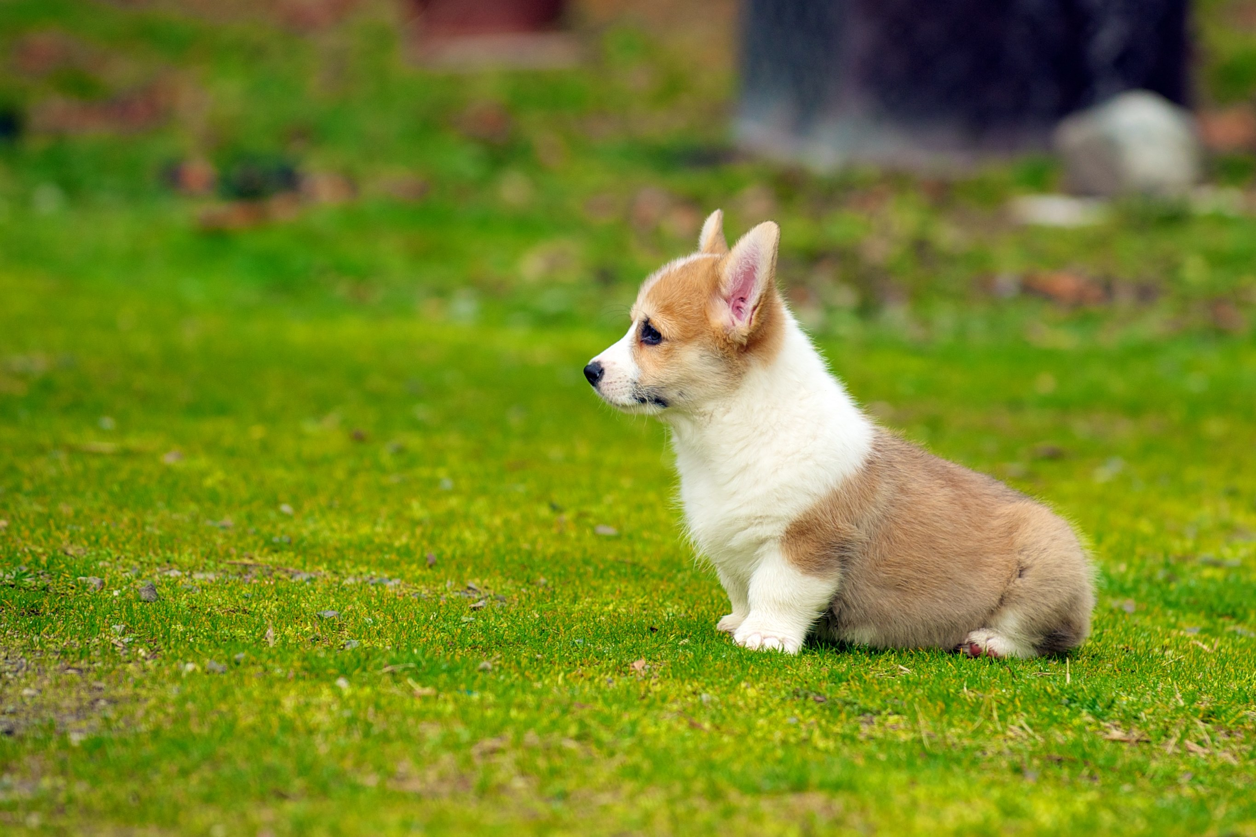
5 - Dogs are playful and energetic. They love being outside and have you playing with them. When dogs are outside they can learn many things, like to do their business outside. Dogs can learn to dig and that could be really helpful. They can also meet other dogs!
6 - What i like about dogs is that they love us so much they go crazy when the doorbell rings,get exited when you come home,and hate it when you are leaving. A reason dogs go crazy when the doorbell rings is because they don't know who or what is behind there and they want to protect you.
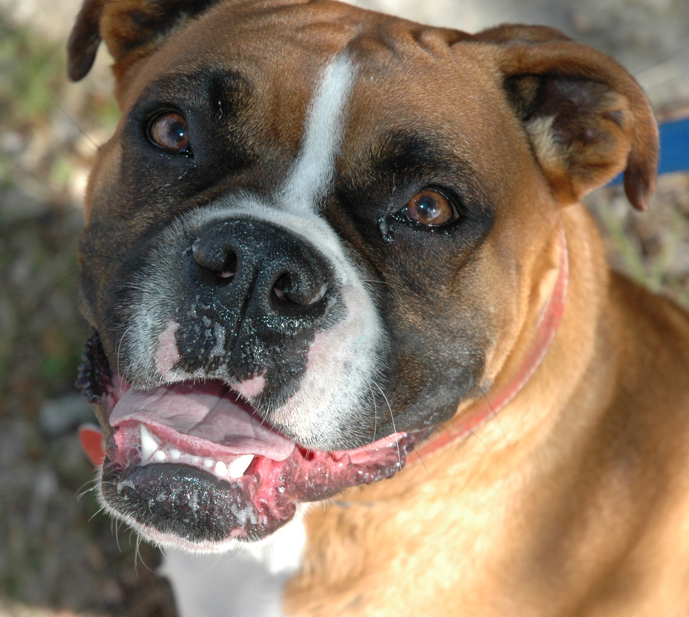
7 - Dogs are really good fluffy friends if you want protection. Dogs can see through the dark and have really good sense of smell and hearing. They know right away when there is an intruder.
8 - If its not clear yet my favorite animal is a dog. All the stuff we read so far are stuff that I like about dogs. I actually have a dog and his name is Mickey! He is hyperactive and loves belly rubs. He doesn't really get along with dogs,but he loves all humans. He is really overprotective and cares for the family.
Thank you for joining me today to talk about my favorite animal. Hope you learned some stuff and liked my presentation. Have a good day!

